ANALYSIS OF ROAD ACCIDENTS AND REGISTERED VEHICLES IN METRO MANILA, PHILIPPINES USING K-MEANS

By
Niña L. Cojena
George S. Mapili

A Thesis Presented for the
Department of Computer Science and Information Technology
Negros Oriental State University, Main Campus 1
In Partial Fulfillment of the Requirements
for the Bachelor of Science in Computer Science

Submitted to
Dr. Guilbert Nicanor C. Atillo

Date
January 2021

Abstract – Traffic accidents are indeed a major area of concern in society because they can result in financial losses as well as a loss of human life. The purpose of this research is to use the K-means clustering algorithm to discover patterns in various features and to get an overview of the number of clusters and to determine cluster members in Metro Manila, Philippines. The Damage to property, Fatal, Non-Fatal of each variables in age bracket, city, time, registered vehicles, and vehicle type are all to consider. Results showed that from nighttime to midnight it is most likely to cause fatal road accidents in Metro Manila. Quezon City has the most number of recorded fatal, non-fatal, and damage to property road accidents. A motorcycle is most likely to cause fatal and non-fatal road accidents compared to other vehicle types. From aged, 18-34 years old bracket is most likely to cause fatal and non-fatal road accidents. There will be a greater number of road accidents when there are a significant number of registered vehicles.
I. INTRODUCTION
According to Thompson, W. H. (1921), “a road traffic accident is defined by the law as a collision involving a vehicle on a road or in a public space that results in damage or harm to a person, an animal, another vehicle, or property”. You can be injured in a road collision whether you were driving, a passenger, walking, riding a bicycle, or riding a horse at the time [2]. An unplanned event that causes damage, injury, or harm is referred to as an accident [3]. As a result, every accident can be considered an incident [3]. However, not every incidence counts as an accident [3].
According to Jacobs et al. (1986), as “the number of motor vehicles and traffic volumes increase, there are many more potentials for traffic accidents. When economic growth is accompanied by an increase in motor vehicles, there is frequently an increase in traffic accidents” [4].
According to a World Bank report from 2017, “between 20 million and 50 million individuals are critically injured in road traffic accidents”. “For children and young adults aged 5–29 years, road traffic injury is now one of the leading causes of death, states World Bank (2017)”. For all age categories, it was classified as the eighth biggest cause of mortality. Vulnerable groups bear a disproportionate share of the burden of traffic-related injuries and deaths. “The burden of road traffic injuries and fatalities is borne disproportionately by vulnerable road users, with an increasing number of fatalities fueled by increasingly motorized transportation (WHO, Global Status Report on Safety 2018)”.
By using K-means clustering, this will cluster out and identify patterns and understand the relationships between variables recorded by the MMDA and LTO. The use of data mining has shown to be a dependable method for evaluating data on traffic accidents and getting results.
The K-Means clustering algorithm is used to accomplish this study. According to Springer, Boston, MA., (2007), Data clustering, also known as data segmentation, seeks to divide a set of data into a predetermined number of subsets (or clusters) that are optimal according to some predetermined criterion function. Data clustering is a fundamental and enabling technology with numerous applications in various fields [5].
II. RELATED LITERATURE
2.1 ROAD CRASHES IN METRO MANILA: OVERVIEW OF ROAD SAFETY by Sophia Francesca DP Lu. College of Arts and Sciences, University of the Philippines Manila
From 2005 to 2014, fatal traffic accidents were studied. The lowest number of fatalities occurred in 2012, with 204, and the largest number of deaths occurred in 2014, with 418. This information is specific for Metro Manila, the Philippines' capital. Non-fatal Accidents were also at an all-time high in 2014, with 16,665 occurrences reported. Property damage reached a high of 73,175 instances in 2014. The most common times for accidents were 10–11 a.m. and 2–3 p.m. Except for a modest fall in 2012, the number of road crashes in the Philippines has gradually increased over the last ten years. The number of cars registered has likewise been steadily increasing. This growth has resulted in increased traffic congestion in Metro Manila, as well as an increased danger of road accidents. This is the first time data on road crash trends in the Philippines has been collected over ten years.

This study looked into trends in fatal and non-fatal injuries caused by road accidents in Metro Manila, Philippines, taking into account all important factors such as property damage, the number of registered cars, and the time of the accident.

III. METHODOLOGY

To get an overview of the number of clusters and cluster centers from existing accident data. We uses the K-Means algorithm to determine cluster members. K-Means algorithm is a clustering algorithm that group’s data based on the center of the cluster (centroid) closest to the data.
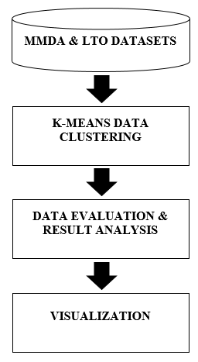

Figure 1: Conceptual Framework

  - Clustering
The K-Means algorithm has the following stages:
1. Define number of K, then randomly chooses K points from the dataset.
2. Then it assigns each point to the group with closest centroid.
3. It again recalculates the centroids.
4. Assign each point to closest centroid.
5. The process repeats until there is no change in the position of centroids.
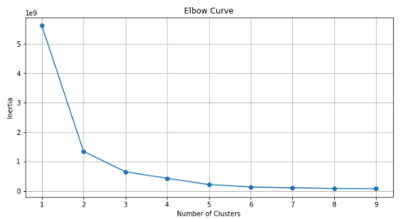
Figure 2: Elbow Curve of Road Accidents in Metro Manila, Philippines by cities.

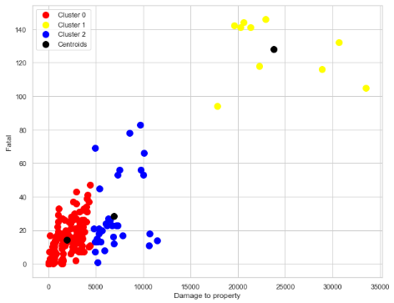Figure 3: Scatterplot of Road Accidents in Metro Manila, the Philippines by cities.

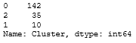
Figure 4: Cluster Instances of K-Means Cluster Model in Metro Manila, the Philippines by cities.

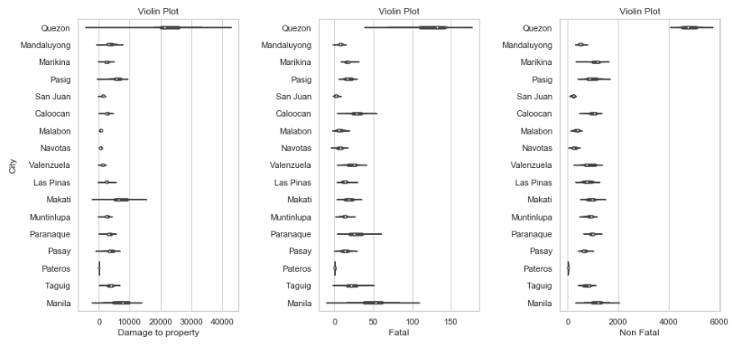

Figure 5: Violin plot of Road Accidents in Metro Manila, the Philippines by cities.

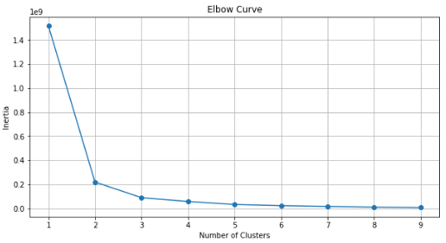
In the Figure 3 shown that Cluster 0 depicts the cities in Metro Manila with the least number of property damage, fatalities, and non-fatal injuries road accidents. In Cluster 1, is the Quezon City is the city with the highest number to damage to property, fatalities, and non-fatal injuries from road accidents. Within Cluster 2 shown the cities having an average number of damage to property, fatalities, and non-fatal injuries. It also shown in the Figure 5 that Quezon City has the highest number of damage to property, fatal, and non-fatal. While the Pateros has the least of all. This potentially provides evidence to support the hypothesis that Quezon City has most road accidents in Metro Manila.

Figure 6: Elbow Curve of Road Accidents in Metro Manila, Philippines by vehicle types.
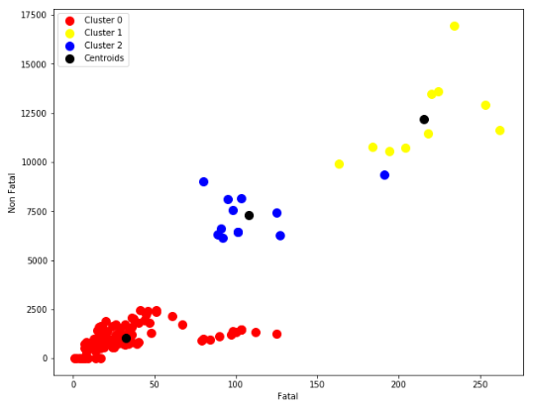

Figure 7: Scatterplot of Road Accidents in Metro Manila, Philippines by vehicle types.
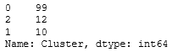

Figure 8: Cluster Instances of K-Means Cluster Model in Metro Manila, Philippines by vehicle types.

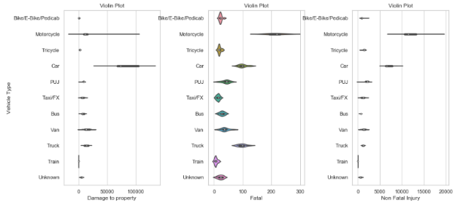

Figure 9: Violin plot of Road Accidents in Metro Manila, Philippines by vehicle types.
It is evident in Figure 7 that the Cluster 2 appears in the middle of the plot, representing an average number of fatal, non-fatal and damage to property of vehicle types. And cluster 1 demonstrates that among vehicle types, motorcycles have a significant incidence of fatal and non-fatal accidents. While cluster 2 depicts a car that has caused the most damage to property as a result of road accidents. It shown in the Figure 9 that motorcycle has the highest number of fatal and non-fatal while the car has the highest number of damage to property. While the train has the least number of all. Cluster 1 potentially suggests that the vehicle type of motorcycle is most likely to have fatal and non-fatal accidents in metro manila.

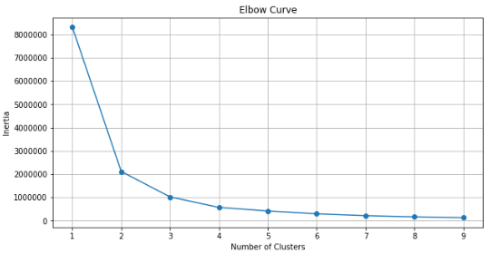
Figure 10: Elbow Curve of Road Accidents in Metro Manila, Philippines by time.

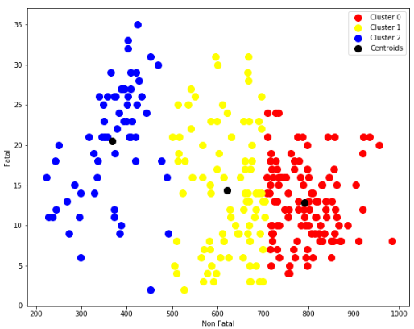Figure 11: Scatterplot of Road Accidents in Metro Manila, Philippines by time.

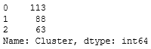

Figure 12: Cluster Instances of K-Means Cluster Model in Metro Manila, Philippines by time.

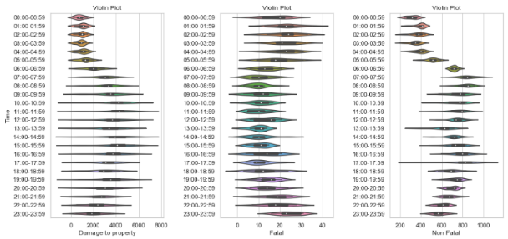
Figure 13: Violin plot of Road Accidents in Metro Manila, Philippines by time.

It is shown in the Figure 11 that the Cluster 0 is most active during daytime-nighttime from 06:00-21:59 or between 6 AM and 9 PM, which corresponds to a significant number of property damage from road accidents. This also shows that Cluster 1 has average number of damage to property, fatal, and non-fatal injuries during daytime to nighttime. While Cluster 2 indicates that it is only active during nighttime and at midnight, from 23:00 to 05:00 or 11 PM to 5 AM, which corresponds to the number of deadly road accidents which also can be seen in the Figure 13. Cluster 2 potentially provides evidence to support the hypothesis that around late nights and midnights are the most likely to have a fatal accident.

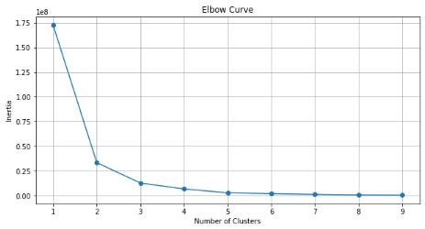
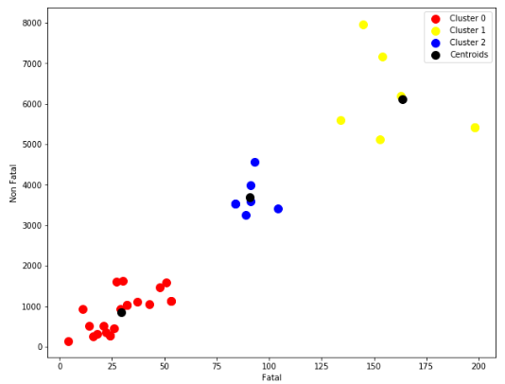Figure 14: Elbow Curve of Road Accidents in Metro Manila, Philippines by age bracket.

Figure 15: Scatterplot of Road Accidents in Metro Manila, Philippines by age bracket.

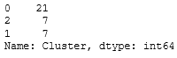

Figure 16: Result of K-Means Cluster Model in Metro Manila, Philippines by age bracket.

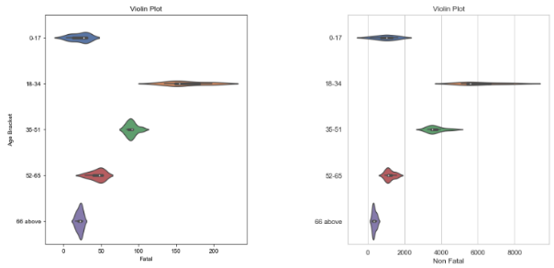
Figure 17: Violin plot of Road Accidents in Metro Manila, Philippines by age bracket.

In Cluster 1 depicts the age brackets of 18-34 years old, which has highest number of fatal, non-fatal injuries. In Cluster 2 depicts the age brackets of 35-51 years old, which has a second to the highest number of fatal, non-fatal injuries. Cluster 0 indicates an age range of 0-17 to 52-66 years old and above, with the least number of fatal, non-fatal injuries. It is also shown in the Figure 16 that age group of 18-34 years old has the highest number of fatal and non-fatal road accidents in Metro Manila. While the age group of 66 years old and above has the least number of road accidents. Cluster 1 potentially suggests that the age group of 18-34 is most likely to have road accidents in metro manila.

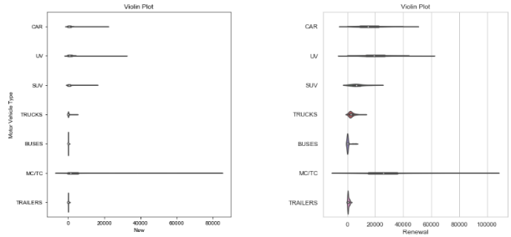

Figure 18: Violin plot of Registered Vehicle in Metro Manila, Philippines by year.

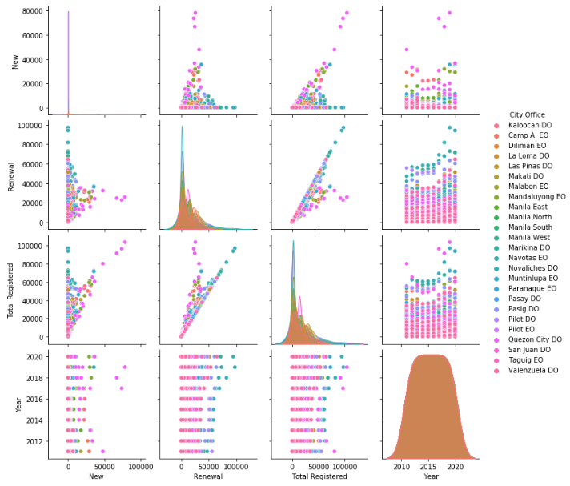Figure 19: Correlation of Registered Vehicle in Metro Manila, Philippines by year.

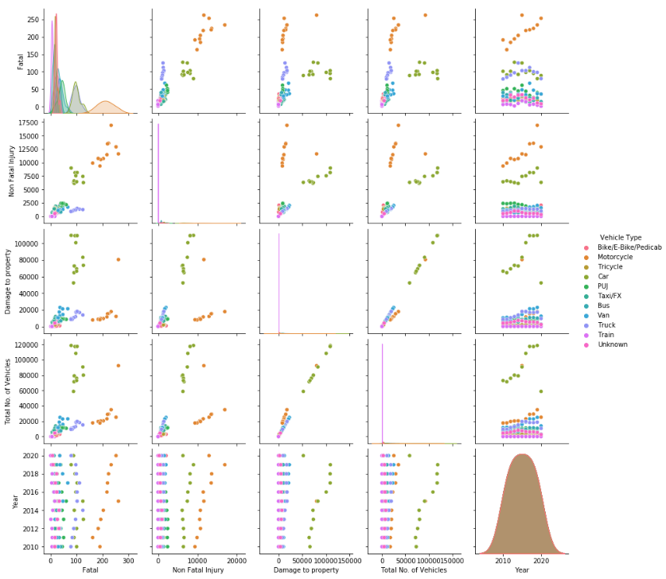

Figure 20: Correlation of Road Accident in Metro Manila, Philippines by year.

It is shown in the Figure 18 that motorcycle/tricycle has the highest number of new and renewal or registered vehicles while the buses has the least number of it, In the Figure 19 shown that the registered of the vehicle has peek around the year 2019. In the Figure 20 also shown that the road accident of motor vehicle has peek around the year 2019. This might indicate that when there are a large number of registered vehicles, there would be a higher incidence of road accidents.

IV. DISCUSSION

4.1 Time and Vehicle Type
According to NSC, “shorter days, exhaustion, reduced night vision, rush hour, and impaired drivers are just a few of the dangers that come with driving at night. [6]”
According to research conducted by the National Sleep Foundation, “60 percent of adults have driven when exhausted –, and there are a variety of reasons for this, including shift work, poor sleep quality, extended work hours, and sleep disorders, and it is not limited to long trips”.
Evening rush hour (between 4 and 7 p.m. on weekdays) is a dangerous time to travel due to congested streets and vehicles anxious to get home after work. During rush hour in the winter, it's dark, adding to an already hazardous situation.
According to the Centers for Disease Control and Prevention, “over 30 people die every day in car accidents involving a drunk driver”. Prescription and other drug-impaired drivers greatly raise this number. Drunk drivers are often prone to be on the road after dark, especially on weekends around midnight and 3 a.m.
Moreover, according to Balmes et al., (2018), motorcycles had the largest percentage of fatal and non-fatal accidents, with 44 percent and 47 percent, respectively. Because motorcycles, unlike four-wheeled vehicles such as cars, have no protection, there are increased chances of fatal and injury incidents when other vehicles collide with motorcyclists [7]. Motorcycles also have a high percentage of fatal and injury incidents due to inappropriate usage of protective equipment, such as helmets [7]. While car accidents can occur for a variety of reasons and are not afraid of people or places [8].
4.2 Cities
Figure 5 show that among the city in Metro Manila, Quezon City has the highest number of road accidents. In 2015, Quezon City ranked first among the LGUs in terms of car accidents, accounting for 28.8% of all incidences. It also has the highest number of fatalities among the LGUs, with 146 deaths in 2015. There were 4,466 people injured and 22,917 homes damaged [10].
It is shown in Figure 5 that the number of road accidents in the Pateros has the lowest of all. The number of traffic accidents in the Pateros is the lowest of all, as indicated in table 5. Since 2013, these LGUs have been regarded as the safest in the city. The MMDA attributes this to their lesser land area and the lack of major arterial routes passing through these LGUs [10].
4.3 Age Bracket
It is evident in Figure 17 that the age bracket of 18-34 has the highest number of road accidents in Metro Manila. Lack of experience, driving while under the influence of drugs or alcohol, using cell phones while driving, and speeding all contribute to a high percentage of accidents among drivers under the age of 25 [11].
Figure 17 shows that the age group of 66 and up has the lowest number of traffic accidents in Metro Manila. Over the age of 65, drivers experience fewer accidents and those that do occur are less serious. The majority of accidents involving this age range are classified as minor claims and are primarily caused by bumper pounding [11].
4.4 Registered Vehicle
According to Jacobs et al. (1986), as the number of motor vehicles and traffic volumes increase, there are many more potentials for traffic accidents. When economic growth is accompanied by an increase in motor vehicles, there is frequently an increase in traffic accidents [4].
V. CONCLUSION
Based on the results, using a K-means algorithm is effective to cluster out the time, vehicle type, city, registered vehicle, and age bracket of Metro Manila, Philippines factors of road accidents. Due to its characteristics and values of the factors of road accidents in Metro Manila, Philippines it is easy to group the results accordingly. The use of the K-means algorithm on the Metro Manila, Philippines road accident dataset supports the hypothesis of the significant factors affecting road accidents. Take a result when found that in time around night and midnight, more involvement of fatal road accidents is presented. This is only one of the many significant findings found in this study.
The study found that when one subfactor changes, it has an impact on the other subfactors that contribute to road traffic accidents. The government must address a more fundamental issue: insufficient and unreliable traffic accident statistics. It would be impossible to not only monitor the level of road traffic safety but also to create and implement cost-efficient road safety initiatives, without building an effective accident report system. With the continuously growing number of vehicles on the road, enhancing road safety is a top priority.
Following the identification of these factors, specific preventive actions targeted at reducing accidents are put in place. It has been determined that there is a need to improve the systematic recording of accident data. It is also possible to reduce road accidents by improving the road accident report forms. In the future, the dataset used in this study might be increased and added. More study is needed to determine how the impact of road accident factors has evolved over time, as well as which variables have been more important in the past and which will become more important in the future.

REFERENCES

[1] Rodriguez, R. L., Villamaria, J. T. B., & Noroña, M. I. (2021, April 5). Analysis of Factors Affecting Road Traffic Accidents in the City of Makati Philippines. ieomsociety.org. Retrieved December 29, 2021, from http://www.ieomsociety.org/brazil2020/papers/602.pdf
[2] Thompson, W. H. (1921). Road traffic accidents: Thompsons Trade Union Solicitors. Thompsons Solicitors. Retrieved December 23, 2021, from https://www.thompsonstradeunion.law/services/road-traffic-accidents
[3] Ltd., M. (n.d.). Accidents and Incidents & Near Misses. What is the difference between accident, incident, and near miss? Retrieved November 19, 2021, from https://www.mangolive.com/what-is-an-accidents-and-incident.
[4] Kopits, E., & Cropper, M. (2005). Traffic fatalities and economic growth. Accident Analysis & Prevention, 37(1), 169–178. DOI: 10.1016/j.aap.2004.04.006
[5] Springer, Boston, MA., (2007). Data Clustering Techniques. In: Machine Learning for Multimedia Content Analysis. https://doi.org/10.1007/978-0-387-69942-4_3
[6] Martin, L. (n.d.). The most dangerous time to drive. National Safety Council. Retrieved December 29, 2021, from https://www.nsc.org/road-safety/safety-topics/night-driving
[7] Balmes, G. T., Tillas, A. W., Zapanta, J. M., Bagabaldo, A. R., & Uy, F. A. (2018, July). Factors Influencing Motorcycle Accident Severity in Commonwealth Avenue, Quezon City, Philippines. ncts.upd.edu.ph. Retrieved December 29, 2021, from http://ncts.upd.edu.ph/tssp/wp-content/uploads/2018/07/TSSP2018-02.pdf
[8] What are the most common causes of auto accidents in urban areas like the Washington, D.C. area, and what do I do if I'm in an accident? Lewis & Tompkins, P.C. (n.d.). Retrieved December 29, 2021, from https://www.lewisandtompkins.com/motor-vehicle-and-public-transportation/car-accidents/car-accidents-questions/what-are-the-most-common-causes-of-auto-accidents-in-urban-areas-like-the-washington-d-c-area-and-what-do-i-do-if-im-in-an-accident/
[9] Mendoza, A. S. (2021, November 21). EDSA, Commonwealth still the most accident-prone roads in Metro Manila. Inquirer Mobility. Retrieved December 29, 2021, from https://inqmobility.com/2021/11/21/autobuzz/edsa-commonwealth-still-the-most-accident-prone-roads-in-metro-manila/
[10] QC, Manila, Makati record most road crashes – MMDA. Retrieved February 4, 2017, from https://www.rappler.com/newsbreak/in-depth/160133-qc-manila-makati-most-road-accidents-mmda/
[11] WHICH AGE GROUP HAS THE MOST ROAD ACCIDENTS? Retrieved July 12, 2019, from https://www.supaquick.com/blog/which-age-group-has-the-most-road-accidents/
BIOGRAPHIES

George Mapili is currently taking up Bachelor of Science in Computer Science at Negros Oriental State University (NORSU), Main Campus 1 from 2018-present. He was born in Dumaguete City, Negros Oriental, Philippines on August 24, 1999.

Niña L. Cojena was born in Balamban, Cebu City, Philippines on January 17, 2000. She is taking up Bachelor of Science in Computer Science at Negros Oriental State University (NORSU), Main Campus 1 from 2018-present. Currently, she is taking her on-the-job training at Negros Oriental Allied Services Company (NOASCO) as an accounting staff, IT assistant, and video advertisement animator

